
Sales Plan

This is a template that provides a sample sales and marketing plan that can be customized for any industry. This template includes information on how to analyze the market, determines the target market, and provides a competitive analysis. In addition, this template can be used to create a custom sales strategy that can help set prices, forecast sales, and determine a marketing budget. This template is ideal for small businesses or other entities that want to ensure effective and efficient marketing strategies.
Sales and Marketing Plan
A guide to developing a successful strategy


2011

TABLE OF CONTENTS
SALES & MARKETING PLAN INTRODUCTION 3
MARKET ANALYSIS 4
Industry Size & Growth 4
Industry Trends 4
TARGET MARKET 5
COMPETITIVE ANALYSIS 6
The Competition 6
Competitive Advantages 6
SWOT Analysis 7
SALES & MARKETING STRATEGY 8
PRICING STRATEGY 10
SALES FORECAST 11
SALES & MARKETING BUDGET 12

SALES & MARKETING PLAN INTRODUCTION
A sales and marketing plan is based on a strategy that effectively communicates the business’s competitive edge and creates value for its target customer base. The purpose of the plan is to assist you with setting goals and to identify the best ways to make your business a success by attracting new customers, creating customer loyalty and in turn increasing sales.

Developing a sound strategy that focuses specifically on your company’s products and/or services can be achieved by carefully considering and incorporating these 7 key elements:

- Market Analysis
- Target Market
- Competitive Analysis
- Sales & Marketing Strategy
- Pricing Strategy
- Sales Forecast
- Sales & Marketing Budget

The following sales and marketing plan serves as an outline and a step-by-step guide through each of the 7 elements, with examples for which you can use to create and customize your own sales & marketing plan.

MARKET ANALYSIS

Industry Size & Growth
In this section,
Provide a brief history of the industry you will be conducting business in.
Highlight the factors that affect growth and discuss future growth projections and opportunities.

For example:
The [Insert your industry sector here] industry has grown by X% over the past decade. Over the five year period from 2003 to 2008, sales grew by 16%. In 2009, there were 36,000 XXX in the US, generating total sales of $X billion.

The [insert industry name here] industry will see continued annual growth of roughly X% over the next five years, primarily as a result of consumer behavior shifts away from ____________ toward _____________.

Other factors include:
- Increasing populations in XXX.
- Better transportation and accessibility (improvement of highway and bridge infrastructures)
- New housing development initiated by the government and the private sector
- Growing demand for __________ driven by ___________.

Industry Trends
Discuss major industry trends.

For example:

The XXX industry continues to move toward _____________ and more analysts project that ______________.

[Insert business sector here] are the traditional destination for consumers looking to ______________. For this reason, [Insert business sector here] sales tend to be noncyclical and homogenous.

Pricing for [include your products/services here] is/are expected to be stable over the next five years. Operating margins will be slightly lower due to increased competition from other __________formats.

[Insert business sector here] generally grow slowly, but produce sufficient cash flow to make the investment worthwhile. Solid cash flow creates flexibility in financing daily operations and allows companies to use debt leverage to increase returns. This is crucial to managing debt, especially considering the average debt for the industry is X% of total capital.

TARGET MARKET
Identify your target market. This is the audience that you plan to sell directly to. Your target may be based on a geographical location, gender, race, age, and/or income level.
For example:
The principal target market for [enter business name here] is X, where the population within one mile of the city center is X.

[Enter target market description here] is primarily comprised of low to moderate income consumers that______________. Based on the 2000 US census, there were X households and the average household income was $X (X% above/below the national average).

If available, include additional studies and recommendation reports here.

COMPETITIVE ANALYSIS

The Competition
Consumers typically have an increasing variety of options to choose from when deciding who and where to purchase products or services from. In this section, list your direct and indirect competition and highlight the following:
- What they do
- How they compare to your business
- Threat level to you
- Strengths/Weaknesses

Barriers to Entry
Barriers to market entry determine how difficult it is to enter a given market. It is important to assess these barriers not only for your own business, but for potential new market entrants. Low barriers to entry make it easier for you to enter the market, however increases the threat of competition.

Barriers to entry include:

- Construction costs
- High Start-up Costs
- Political and Governmental Regulations

Competitive Advantages
List your competitive advantages.

For example,

[Enter company name here] has the following advantages over its competition:
- Variety of products and services unique to the community
- One-stop shopping experience
- Complimentary transportation
- Central location
- Employment opportunities for X people
- High quality at low prices
- Excellent customer service

SWOT Analysis
A SWOT analysis is used to determine the overall strengths, weaknesses, opportunities and threats that influence a company’s ability to compete in the marketplace. Compile a list for your business and then develop a strategy.
Use the SWOT chart below as a reference.

 | Overcome weaknesses to pursue opportunities
Pursue opportunities that fit with strengths | Strengths | Weaknesses | Establish a defensive plan to minimize threats
Pursue opportunities that fit with strengths | - Central location in community  - Community based employees  - High quality operational procedures  - In-house employee training and cross training program  - Competitive pricing | - Location not in heavy traffic area  - Poor community reputation  - Market vacated by ineffective management  - Undifferentiated products  - Establishing initial product mix | Establish a defensive plan to minimize threats
Pursue opportunities that fit with strengths | Opportunities | Threats | Establish a defensive plan to minimize threats
Pursue opportunities that fit with strengths | - Strong online presence  - Marketing alliances  - Unmet demand in business sector  - Community involvement & support  - Economic powerhouse for local market | - Economic downturns  - Inflation  - Intolerable supplier/distributor price increases  - Regulatory changes  - Increased competition | Establish a defensive plan to minimize threats

SWOT Strategies
SO: Take advantage of business location, where there are no other similar businesses. Provide transportation to gain customers and increase sales.

WO: Closely monitor purchasing trends and customer demand to establish the appropriate product mix.
OT: Partner with churches, senior communities and chamber of commerce.

TS: Focus on community development and involvement. Market to nearby communities with limited shopping resources

SALES & MARKETING STRATEGY

A marketing strategy is a plan that identifies the best way for the company to use its resources to increase sales.

There are several different strategies and tactics to consider. Below are examples of tactics and how they can be used to increase sales.

Trademarks, Logos & Slogans
In the start-up phase of a business venture, it is important to establish name recognition in the form of trademarks, logos, and/or slogans to deliver a clear and consistent message of who the company is and what it has to offer. These items should appear on all sales and marketing related materials.

Print advertisements
This form of advertisement is a relatively inexpensive way to reach out to large audiences. Place ads in local newspapers and magazines and feature special offers and discounts.

Direct Mailings
Direct mailings are not only a way to attract initial customers but also to retain them. Mailings may consist of brochures, coupons, or a monthly newsletter.

TV/Radio Commercials
Commercials on local television stations, local cable access channels and the radio are an effective means to reaching out to large audiences. Determine the broadcast frequency and channel selections appropriate for your business and budget.

Web and E-mail Marketing
Web and email marketing is one of the most popular and cost effective marketing tools. Consider hiring a website development agency to develop and maintain a state-of-the-art website and a social media presence online.

Word of Mouth
Word of mouth advertising can be the most powerful form of advertising, and it’s free. Focus on establishing a sound reputation by providing excellent customer service, offering quality products and services, and creating a customer-friendly environment.

Public Relations
The importance of creating and maintaining public interest and goodwill in the community that you serve is vital to your business’s success and positive reputation.
- Consider participating in local community events
- Become a member of an organization or association correlated to your business.
- Register with the Better Business Bureau and/or the Chamber of Commerce.

Customer Surveys
To improve the effectiveness of your marketing and sales efforts, create monthly customer surveys that focus on the behavioral and psychographic attributes of your customers.

Survey questions should focus on:
- Customer purchase habits, demographic data and other criteria to determine the response behavior of your customers.

- Psychographic variables that influence customer perception and preferences. These variables may include lifestyle, personality type, values, interests, attitudes and motivation.

Offer incentives to customers for completing the surveys.

Sales Promotions
Sales promotions often serve as an effective way to temporarily boost sales. Sales promotions may include temporary price reductions, coupons, and free samples. Try to be creative in your sales efforts and consider a variety of sales promotions and tactics. Also, keep track of what your competition is doing and offering. Consider offering a comparable or better promotion when necessary.

Marketing Alliances
Establish marketing partnerships with other businesses to offer joint promotions, special offerings, and the benefits of advertisement exchanges.

Customer Service
The goal of your company should be to provide superior service to its customers by hiring friendly, outgoing staff, with appropriate skill sets and competency levels. Providing excellent customer service is critical to a successful marketing strategy.

PRICING STRATEGY
There are several different pricing strategies that a business may decide to use to attract customers and maximize profits. The decision is primarily based on the nature of the products or services being offered and how a business prefers to position itself in the marketplace. The most commonly used pricing strategies include:

Penetration Pricing – This form of pricing is used to attract new customers and to establish a presence in the market. This strategy will allow a company to quickly gain market share. Prices are set low at first, and then raised after market share has been gained.

If demand for your products and services is elastic, and your customer base is price sensitive, this pricing strategy will serve as the most appropriate means for achieving high sales volume in the short term.

Penetration pricing is a strategy commonly used by new businesses.

Premium Pricing – Premium pricing is primarily used by those businesses operating in a niche, specialty or luxury market, where products or services being offered are unique, rare or extravagant. Pricing remains high as long as there is a distinct competitive advantage.

Economy Pricing – This form of pricing is very straightforward. The pricing strategy is based on offering products and services at the lowest cost possible.

Price Skimming – Price skimming is best used for new products or services, where there is no immediate direct competition. Initially, pricing is set high. However, when competition arises and similar products are introduced to the market, the pricing is typically driven down. This occurs often within the consumer electronics industry.

SALES FORECAST
It is imperative to project both monthly and annual sales forecasts for your business. The forecasts should be consistent with your company’s marketing goals and objectives. Also, your projections should be conservative and realistic.

The two sample charts below capture Monthly and Annual Sales Forecasts. Include your company’s forecasts here. Also, explain what the sales forecasts are based on and exactly how they will be achieved.



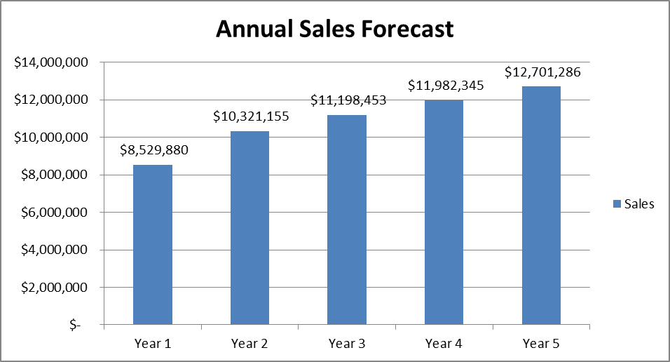

SALES & MARKETING BUDGET
A sales and marketing budget is very helpful in planning how and where to concentrate your efforts and dollars, and is typically 2 - 50% of total sales, yet can be higher for new businesses. To establish an appropriate budget for your business, use industry averages and compare your budget to that of your competition when possible.

The sample chart below is based on an $180,000 sales and marketing budget.

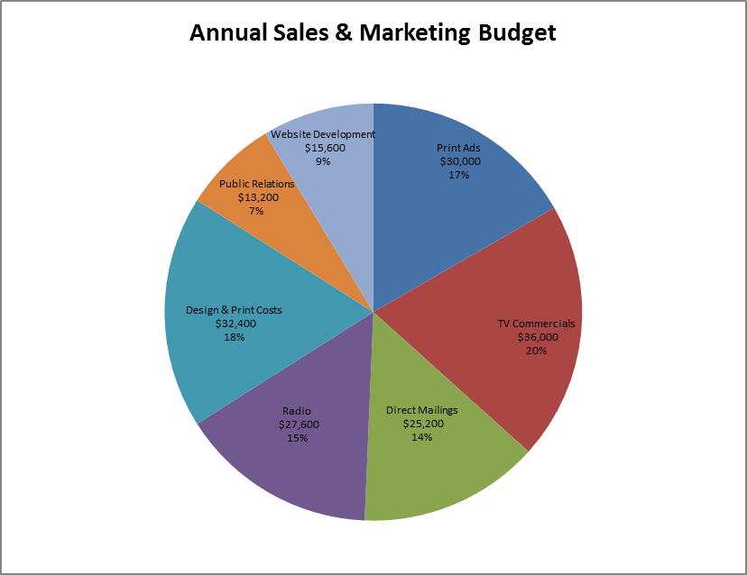
INFORMATION AND FORMS ARE PROVIDED "AS IS" WITHOUT ANY EXPRESS OR IMPLIED WARRANTY OF ANY KIND INCLUDING WARRANTIES OF MERCHANTABILITY, NONINFRINGEMENT OF INTELLECTUAL PROPERTY, OR FITNESS FOR ANY PARTICULAR PURPOSE. IN NO EVENT SHALL DOCSTOC, INC., OR ITS AGENTS, OFFICERS, ATTORNEYS, ETC., BE LIABLE FOR ANY DAMAGES WHATSOEVER (INCLUDING, WITHOUT LIMITATION, DAMAGES FOR LOSS OF PROFITS, BUSINESS INTERRUPTION, LOSS OF INFORMATION) ARISING OUT OF THE USE OF OR INABILITY TO USE THE MATERIALS, EVEN IF DOCSTOC HAS BEEN ADVISED OF THE POSSIBILITY OF SUCH DAMAGES. They are for guidance and should be modified by you or your attorney to meet your specific needs and the laws of your state or jurisdiction. Use at your own risk. Docstoc® is NOT providing legal or any other kind of advice and is not creating or entering into an Attorney-Client relationship. The information, reports, and forms are not a substitute for the advice of your own attorney. The law is a personal matter and no general information or forms or like the kind Docstoc provides can always correctly fit every circumstance.

Note: Carefully read and follow the Instructions and Comments contained in this document for your customization to suit your specific circumstances and requirements. You will want to delete the Instructions and Comments from open bracket (“[“) to close bracket (“]”) after reading and following them. You (or your attorney) may want to make additional modifications to meet your specific needs and the laws of your state. The Instructions and Comments are not a substitute for the advice of your own attorney.

◊ Where within this document you see this symbol: ◊ or an instruction states “Insert any number you choose◊,” or something similar, or there is a blank for the user to complete, please note that although Docstoc believes the information or number may be any that the user chooses, and that there is no law governing what the information or number should be, you might want to verify this, including by consulting with your own attorney practicing in your state. Because the law is different from jurisdiction to jurisdiction and the laws are subject to change, Docstoc cannot guarantee—and disclaims all guarantees—that it is correct for the information or number to be anything that the user chooses.

The information, forms, instructions, tips, comments, decision tree alternatives and choices, reports, and services in and through Docstoc are not legal advice, but are general information / forms on general issues often encountered designed to help Docstoc users, members, purchasers, and subscribers address their own needs. But information, including tips, general forms, instructions, comments, decision tree alternatives and choices, and reports, no matter how seemingly customized to conform to the laws and regulations applicable to you, is not the same as legal advice, which may be the specific application of laws and regulations by lawyers licensed to practice law in your state to the specific circumstances and needs of individuals and entities. Some states, counties, municipalities, and other governmental divisions, have highly specific laws and regulations, and our information / forms / reports may not take all those specific laws and regulations into consideration, although we tried to do so.

Docstoc is not a law firm and the employees and contractors (including attorneys, if any) of Docstoc are not acting as your attorneys, and none of them are a substitute for the advice of your own attorney licensed to practice law in your state. The employees or contractors of Docstoc, who wrote or modified any form, instructions, tips, comments, decision tree alternatives and choices, and reports, are NOT providing legal or any other kind of advice and are not creating or entering into an Attorney-Client relationship. Any such form, instruction, tips, comments, decision tree alternatives and choices, and reports were most likely NOT prepared or reviewed by an attorney licensed to practice law in your state, and, therefore, the employees or contractors could not provide you with legal advice even if they or Docstoc wanted to. Even though we take every reasonable effort to attempt to make sure our information / forms / reports are accurate, up to-date, and useful, we recommend that you consult a lawyer licensed to practice law in your state if you want professional assurance that our information, forms, instructions, tips, comments, decision tree alternatives and choices, and reports; your interpretation of it or them; and the information and input that you provide are appropriate to your particular situation. Application of these general principles and wording to particular circumstances should be done by a lawyer who has consulted with you in confidence, learned all relevant information, and explored various options. Before acting on these general principles and general wording, you might want to hire a lawyer licensed to practice law in the jurisdiction to which your question pertains. The information, forms, instructions, tips, comments, decision tree alternatives and choices, and reports, available on and through Docstoc are not legal advice and are not guaranteed to be correct, complete, accurate, or up-to-date. Because the law is different from jurisdiction to jurisdiction, they are subject to changes, and there are varying interpretations and applications by different courts and governmental and administrative bodies, and Docstoc cannot guarantee—and disclaims all guarantees—that the information, forms, and reports on or through the site and services are completely current or accurate. Please further note that laws change and are regularly amended; therefore, the provisions, names, and section numbers of statutes, codes, or regulations, and the types of permits or licenses within any forms or reports, may not be 100% correct, as they may be partially or wholly out of date and some relevant ones may have been omitted or misinterpreted.
Docstoc is not permitted to engage in the practice of law. Docstoc is prohibited from providing any kind of advice, explanation, opinion, or recommendation to a consumer about possible legal rights, remedies, defenses, options, selection, or completion of forms or strategies.
Communications between you and Docstoc may be protected by our Privacy Policy (http://premium.docstoc.com/privacypolicy), but are NOT protected by the attorney-client privilege or work product doctrine since Docstoc is not a law firm and is not providing legal advice. No Docstoc employee, contractor, or attorney is authorized to provide you with any advice about what information (again, which includes forms) to use or how to use or complete it or them.

Entire document copyright © Docstoc®, Inc., 2010 - 2013 All Right Reserved

